Sunday 1st April
Craft:
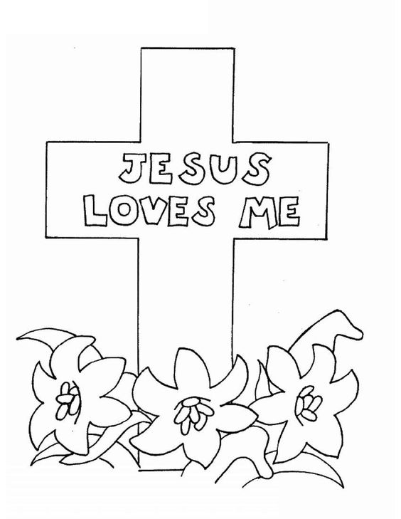
Story: Easter story
Easter Sunday….. Let’s talk with the children how Jesus loves them. And what he did for them.
Songs: This little light of mine
Our God is a great big God
Jesus loves me this I know for the bible tells me so.

