Week 7 Fruit of the spirit
All together
Craft: finger paint the tree then have the children stick on the fruits.
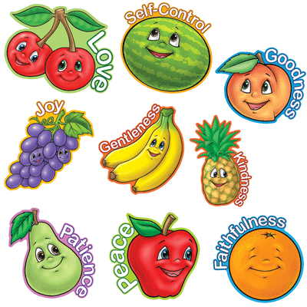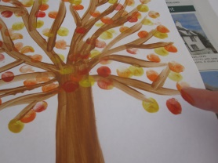
Disussion: Talk with the children about all God has done for them. How much he loves them.

Use the bubbles to encourage them to come to the carpet.
Song this term……
God’s love is higher than the mountains (point up)
Deeper than the sea (point down)
Wider than the biggest hill (stretch arms wide)
Is how much God loves me (cross arms over chest)
Please feel free to use the song board again this term

