Sunday 24th September – Riverside Materials, Vision Sunday
These materials are designed to offer something for every age, so do please pick the appropriate parts for the group you are leading, and feel free to add your own ideas!
Bible Verses John 13;1-5
Key verse ; Jesus knew….that he had come from God and was returning to God’ vs 3
Key message; To encourage the children to know who they are in God, and to encourage a deeper relationship with him.
Activity
As an introductory activity, why not wash the children’s feet?
There are bowls in the kitchen and blue roll in your boxes
This can be a very unexpected activity for the children but one that can be surprisingly calming and really helps to break down barriers and build relationships. After you have washed their feet, they may want to wash one another’s?
Talk
Why did we start by washing your feet today?
How did it feel?
Do you know a story from the bible where someone washes their friend’s feet?
Read the bible story for today; John 13; 1-5. Key verse 3
Explain the cultural context of washing feet – in bible times it was a job the servants did, the lowest people
Jesus was not concerned about position, he knew who he was and he was confident in this, so he humbled himself in washing his disciple’s feet. Jesus was prepared to be a servant, he had no need to put himself above others.
How does that make you feel?
What does this tell us about Jesus? (he was confident, knew who he was, humble, loved his disciples…)
Are you important? Are you confident?
What does humble mean?
Have you ever asked God who you are or what he loves about you?

Chat and catch
Chat
What makes you different from everyone else?
Get them to think and share about this.
Every child has a special God given talent, some will know this some may not yet – what are you good at?
Share what you are good at too – often leading the way helps the children
Who does God say you are? What does God love about you? – again, leading the way and sharing for yourself often helps
Catch
Why not put some quiet worship music on and get the children to hear God for themselves
Some children find this easier sitting on ‘special spots’ (Jellies through Starburst, some find it helpful to have pen and paper or even plastecine)
Who does God say they are? What does he love about you?
Has he shown them something new?
Do they have anything to share for someone else in the group?
From this activity, the craft should flow quite naturally
Craft;
Starburst, Skittles, Ignite
There are ‘people’ key rings for the children to make. Encourage them to take their time, think about who they are, who God says they are and try and depict this in some way with their key ring. They may want to out a word or bible verse on the back
Smarties and Jellies
There are ‘people’ cut outs for photocopying at the end of this material. Get the children to think about who they are, what makes them special, how has God made them? Then decorate the picture as represent themselves. Consider getting some wool, tissues paper or other resources from the upstairs cupboard to make this more fun!

Games
There are a couple of getting to know you games you could use with the older children that can read.
You could also use the Bible passages that tell us who we are, for a sword drill?
For the younger children – why not try some parachute games? As the parachute lifts up, run to the other side if…. You have blue eyes, if you are good at running, if you have a bible at home, if you are friends with Jesus!....etc
You could use the number line game to find out what special gifts and talents the children have. Line up paper plates the length of the room that have the numbers 1-10 on them. 10 means brilliant, the best, 1 means definitely not, the worst, and the numbers in between are a sliding scale. So then you ask the children a series of questions….
How good are you at football – the children run to where they think they are, good (10), awful (1) or something in between. How good are you at maths, reading your bible, building lego constructions, eating chocolate! etc

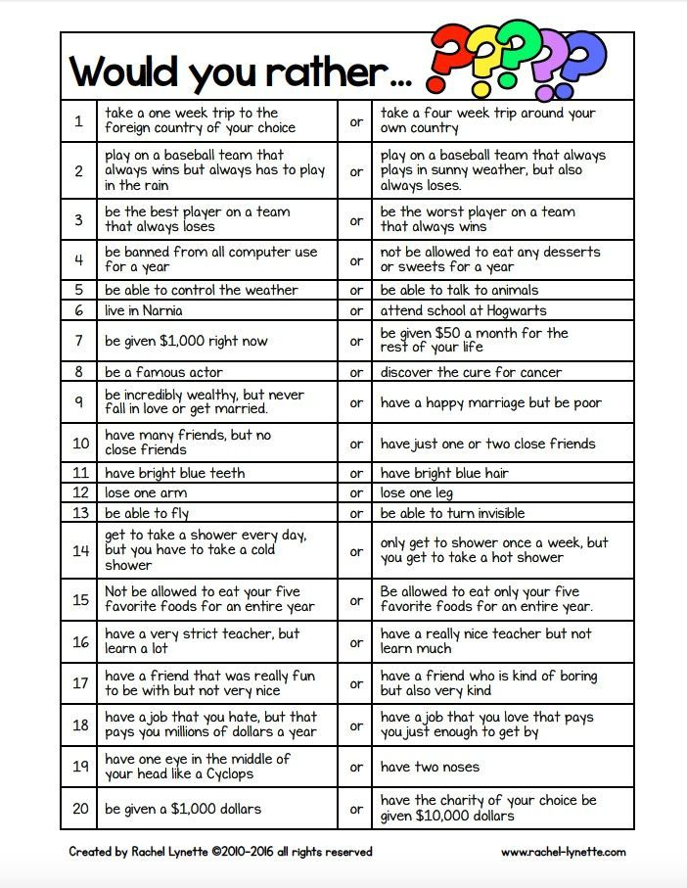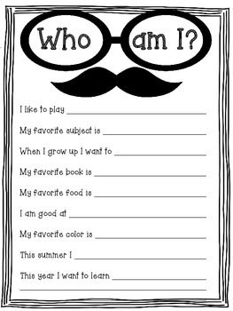

• I am a child of God. John 1;12
• I am a friend of Jesus. John 15;15

• I am no longer a slave to sin. Romans 6;6

• As a child of God, I am a fellow heir with Christ Romans 8;17

• I have been accepted by Christ romans 15;7

• My body is a temple of the Holy Spirit who dwells in me 1 Corinthians 6;19.

• I am a new creature in Christ. 2 Corinthians 5;17

• I am no longer a slave, but a child and an heir. Galatians 4;7

• I have been set free in Christ. Galatians 5;1

• I am chosen, holy, and blameless before God. Ephesians 1;4

• I am redeemed and forgiven by the grace of Christ. Ephesians 1;7

• I have been made alive with Christ. Ephesians 2;4-5

• I am God’s workmanship created to produce good works. Ephesians 2:10

• I am a citizen of heaven. Philippians 3:20

• God supplies all my needs. Philippians 4:19

• I have been raised up with Christ. Colossians 3:1

• I have been chosen of God, and I am holy and beloved. Colossians 3:12

• God loves me and has chosen me. 1Thessalonians 1;4

