Sunday 7th January- Jellies Material
The Parable of the Lost Sheep.
Craft: Get Children to make sheep masks using templates, by colouring in and sticking on cotton wool. Cut out masks for children and attach lollypop sticks for them to hold with.
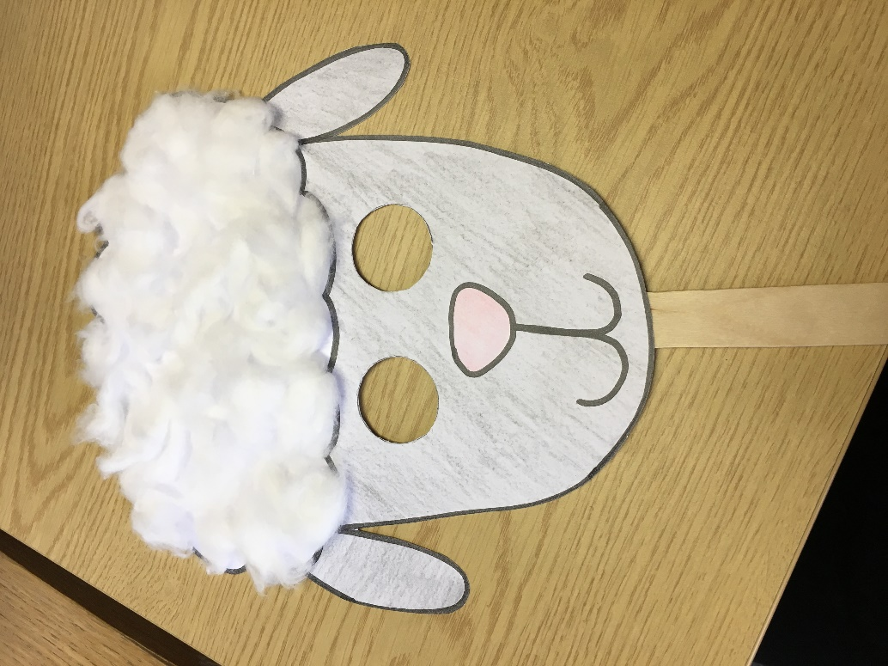
Story: Act out the parable of the lost sheep taken from Luke 15:1-7, using the children as sheep (If they’ve made a mask they can use this to pretend to be sheep). Choose one child to be the shepherd or be the shepherd yourself. Talk about how God always comes looking for us and wants to carry us back to safety on his shoulders. He cares for us very much and each one of us is special to him.
Pray and thank God for his love for each of us.
Songs: The Baa Baa Song (He’s the Good Shepherd) –Youtube
https://www.youtube.com/watch?v=PGPQX3vQtU8
Video: You can use this video to back up the story you have acted out. https://www.youtube.com/watch?v=tyWZeOlaRo4

