Sunday 12th November
Aim: To speak to the children about being different.
Craft: Paper plate faces
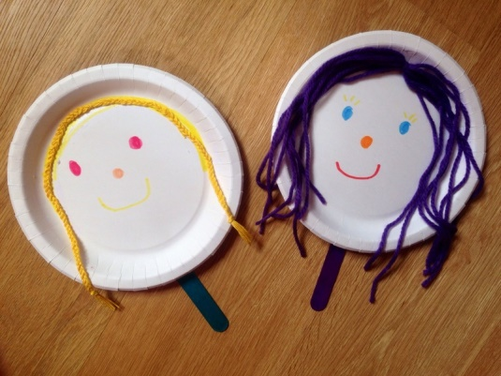

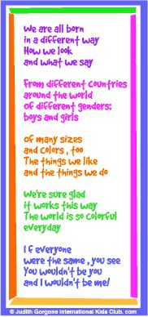
Use these words with the paper plates the children have done. Encourage them to join In with some of the words.
Maybe play a game with the children to see who has the same colour clothes, shoes hair colour etc…..

