God created………..
Week 5: Sun moon and stars.
Activity: 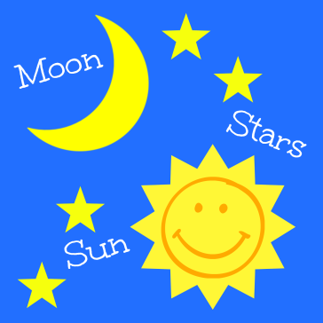 Use the pictures to stick onto blue paper.
Story: Have the children find pictures around the room, of sun moon and stars. These will be available for you to put onto the walls and blue boards.

Use bubbles (Adult use only) to encourage the children to come and sit on the mat.
Use the song board provided…. Let the children who are sitting nicley choose a song to sing.

