Name That Biscuit!
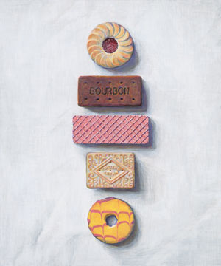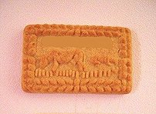
1

2

3

4

5

6

7

8
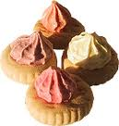
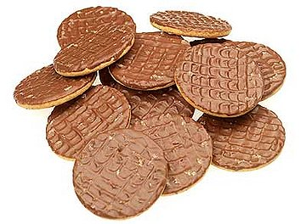

10
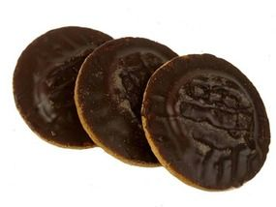
9

10

11

12

13

7

8
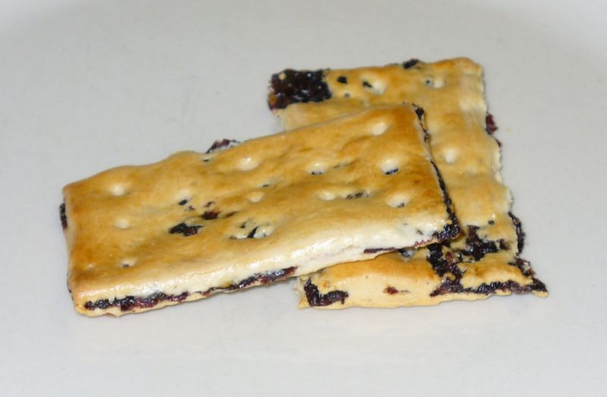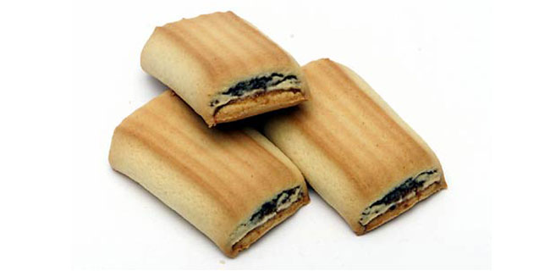
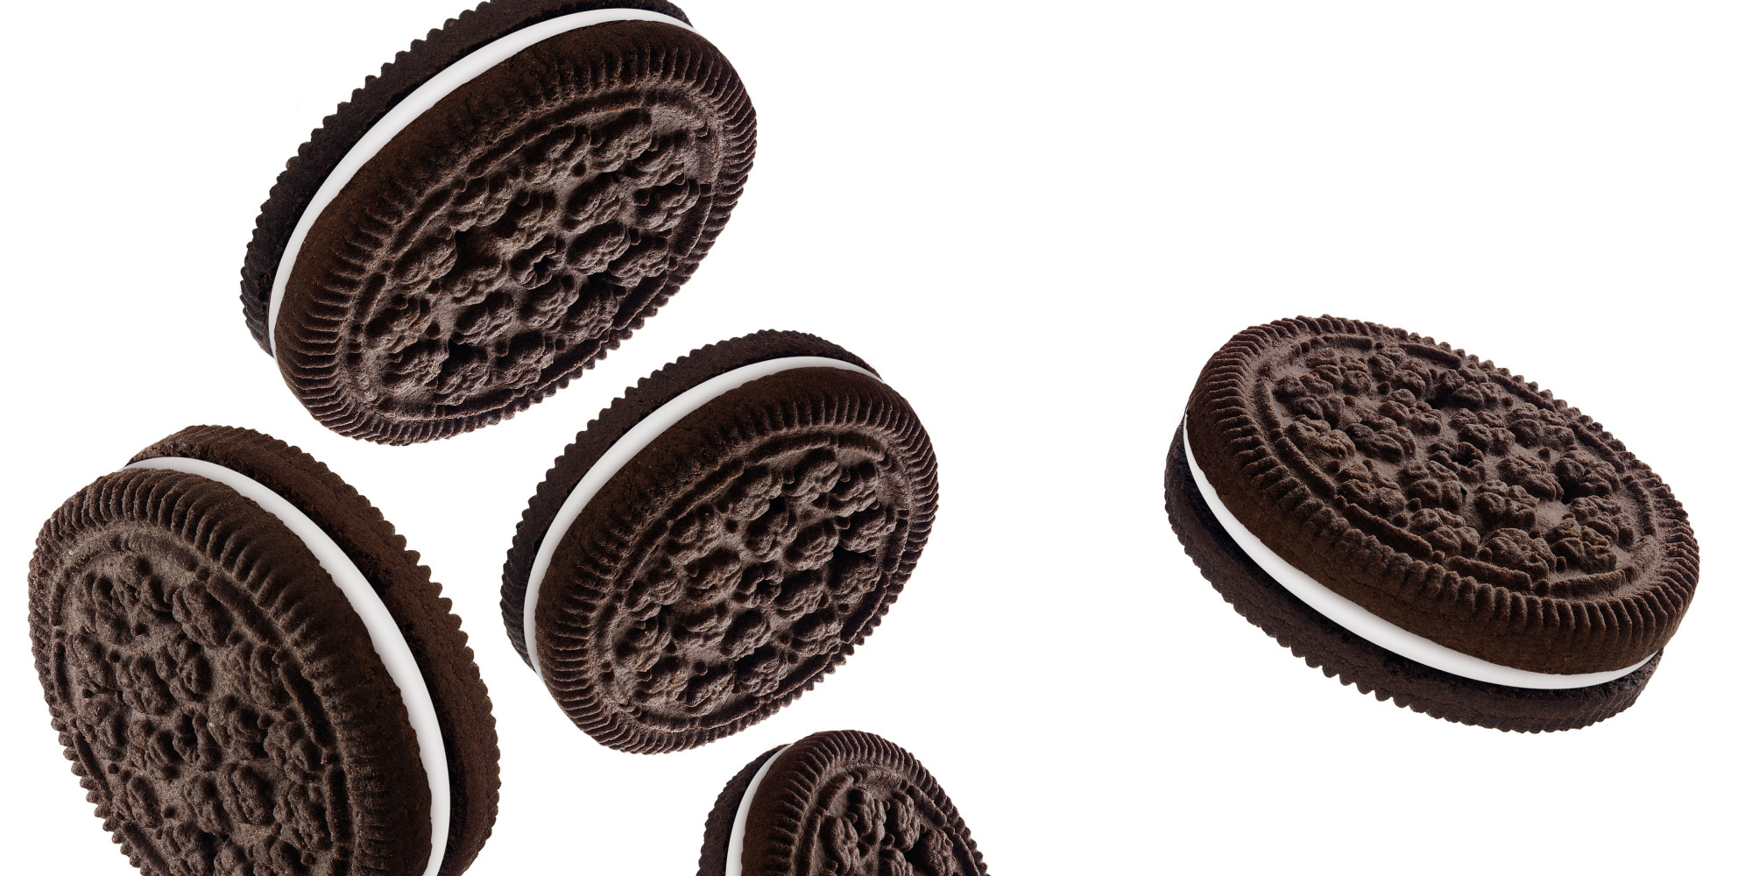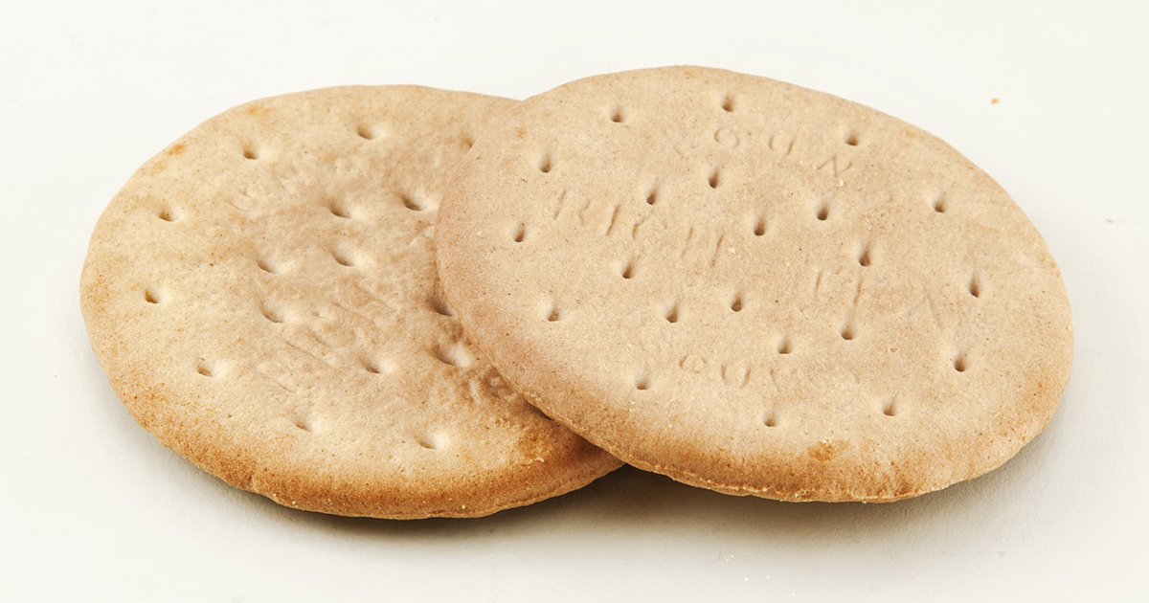
Answers
1 Jammy Dodger
2 Bourbon
3 Pink Wafer (or pink panther wafer)
4 Custard Cream
5 Party Ring
6 Malted milk
7 Iced gems
8 Chocolate digestives
9 Jaffa Cakes
10 Garibaldi (or squashed fly biscuits!)
11 Fig rolls
12 Oreo
13 Rich Tea Biscuits

